**ASSIGNMENT**

**(SE - Overview of IT Industry)**

# 1) What is software? What is software engineering?

Ans: Software is a set of programs (sequence of instructions) that allows the users to perform a well-defined function or some specified tasks. Software directs all computer-related devices and instructs them regarding what and how the task is to be performed. However, the software is made up of binary language (composed of ones and zeros).

Software Engineering is the process of designing, developing, testing and maintaining software. It is a systematic and disciplined approach to software development that aims to create high quality, reliable and maintainable software. It includes a variety of techniques, tools and methodologies including requirements analysis, design, testing and maintenance.

# 2) Explain types of software

Ans: There are five types of software:

* Application software
* System software
* Driver software
* Middleware
* Programming software

**Application Software:** The most common type of software, application software is a computer software package that performs a specific function for a user, or in some cases, for another application. An application can be self-contained, or it can be a group of programs that run the application for the user. Examples of Modern Applications include office suites, graphics software, databases and database management programs, web browsers, word processors, software development tools, image editors and communication platforms. Example: Microsoft Office, Paint, PowerPoint etc...

**System Software:** These software programs are designed to run a computer's application programs and hardware. System software coordinates the activities and functions of the hardware and software. It controls the operations of the computer hardware and provides an environment or platform for all the other types of software to work in. The OS is the best example of system software; it manages all the other computer programs. Other examples of system software include the firmware, computer language translators and system utilities. Example: Notepad ,Calculator etc.

**Driver Software:** Also known as device drivers, this software is often considered a type of system software. Device drivers control the devices and peripherals connected to a computer, enabling them to perform their specific tasks. Every device that is connected to a computer needs at least one device driver to function. Examples include software that comes with any nonstandard hardware, including special game controllers, as well as the software that enables standard hardware, such as USB storage devices, keyboards, headphones and printers. Example: Audio Driver, Video Driver etc.

**Middleware:** The term middleware describes software that mediates between application and system software or between two different kinds of application software. For example, middleware enables Microsoft Windows to talk to Excel and Word. It is also used to send a remote work request from an application in a computer that has one kind of OS, to an application in a computer with a different OS. It also enables newer applications to work with legacy ones. Example: database middleware, application server middleware.

**Programming Software:** Computer programmers use programming software to write code. Programming software and programming tools enable developers to develop, write, test and debug other software programs. Examples of programming software includes assemblers, compilers, debuggers and interpreters. Examples : Turbo c, Eclipse, Sublime etc.

# 3) What is SDLC? Explain each phase of SDLC

Ans: Software Development Life Cycle (SDLC) is a framework that defines the steps involved in the development of software at each phase. It covers the detailed plan for building, deploying and maintaining the software. SDLC defines the complete cycle of development i.e., all the tasks involved in planning, creating, testing, and deploying a Software Product.

The phases of SDLC are:-

* Requirement gathering and analysis
* Design
* Implementation or coding
* Testing
* Deployment
* Maintenance

**Requirement gathering and Analysis:** During this phase, all the relevant information is

collected from the customer to develop a product as per their expectation. Any ambiguities must be resolved in this phase only. Business analyst and Project Manager set up a meeting with the customer to gather all the information like what the customer wants to build, who will be the end-user, what is the purpose of the product. Before building a product a core understanding or knowledge of the product is very important.

**Design:** In this phase, the requirement gathered in the SRS document is used as an input and software architecture that is used for implementing system development is derived.

**Implementation or coding:** Implementation/Coding starts once the developer gets the Design document. The Software design is translated into source code. All the components of the software are implemented in this phase.

**Testing:** Testing starts once the coding is complete and the modules are released for testing. In this phase, the developed software is tested thoroughly and any defects found are assigned to developers to get them fixed.

Retesting, regression testing is done until the point at which the software is as per the customer’s expectation. Testers refer SRS document to make sure that the software is as per the customer’s standard.

**Deployment:** Once the product is tested, it is deployed in the production environment or first [UAT (User Acceptance testing)](https://www.softwaretestinghelp.com/what-is-user-acceptance-testing-uat/) is done depending on the customer expectation. In the case of UAT, a replica of the production environment is created and the customer along with the developers does the testing. If the customer finds the application as expected, then sign off is provided by the customer to go live.

**Maintenance:** After the deployment of a product on the production environment, maintenance of the product i.e., if any issue comes up and needs to be fixed or any enhancement is to be done is taken care by the developers.

# 4) What is DFD? Create a DFD diagram on Flipkart

Ans: A data flow diagram (DFD) maps out the flow of information for any process or system. It uses defined symbols like rectangles, circles and arrows, plus short text labels, to show data inputs, outputs, storage points and the routes between each destination.

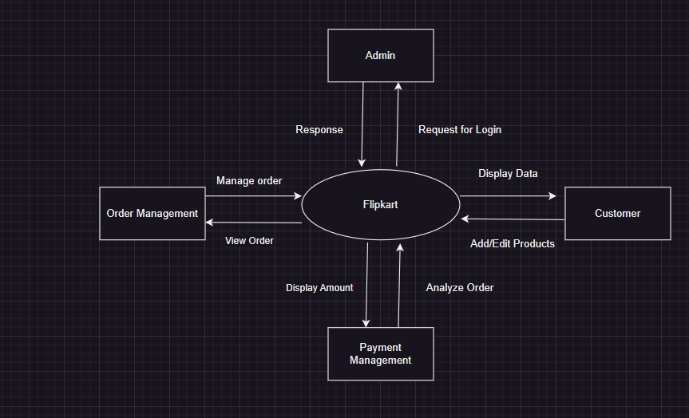

# 5) What is Flow chart? Create a flowchart to make addition of two numbers

Ans: A flowchart is a type of diagram that represents a process or algorithm.

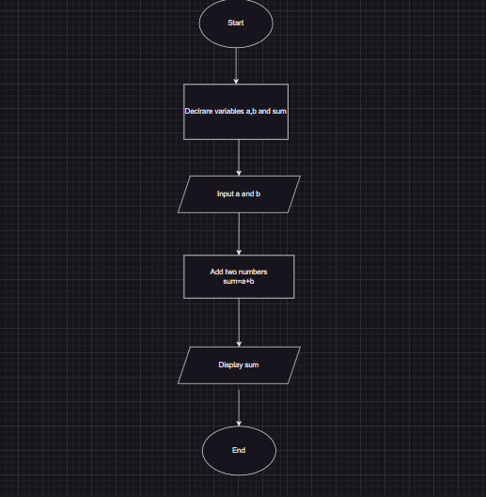

# 6) What is Use case Diagram? Create a use-case on bill payment on Paytm.

Ans: A use case diagram is a graphical depiction of a user's possible interactions with a system. A use case diagram shows various use cases and different types of users the system has and will often be accompanied by other types of diagrams as well.

